Temasek Polytechnic

School of Informatics and IT

**Diploma in Information Technology (IT)**

Project Plan

**Project Particulars**

|  |  |
| --- | --- |
| **Tutor** | Mr Qi Yutao |
| **Class** | T04 |
| **Project Title** | Hotel Management System |

**Project Team’s Particulars**

|  |  |
| --- | --- |
| **Matric Number** | **Student Name** |
| **1703208G** | **Berwin Leong Jun Wen** |
| **1702625C** | **Soo Yuan** |
| **1700803H** | **Ting Chao Chong** |
| **1704144C** | **Muhammad Ismail B.M.I** |

**Revision History**

|  |  |  |  |
| --- | --- | --- | --- |
| **Date** | **Version** | **Description** | **Author** |
| <11/11/2018>  To  <11/11/2018> | <1> | We did Introduction | Berwin and Soo Yuan |
| <12/11/2018>  To  <13/11/2018> | <2> | We did Roles and Responsibilities | Everyone |
| <14/11/2018>  To  <17/11/2018> | <3> | We did Estimates and Project Schedule | Berwin,Soo Yuan and Ismail |
| <17/11/2018>  To  <18/11/2018> | <4> | Chao Chong did Risk management plan | Chao Chong |

Table of Contents

1. Introduction

1.1. Objectives and scope of the project

1.2. Assumptions and constraints

1.3. Definitions and acronyms

2. Roles and responsibilities

3. Estimates and project schedule

3.1. Work breakdown structure

3.2. Project schedule

3.3. Budget summary

4. Risk management plan

**Project Plan**

**1 Introduction**

1.1 Objectives and scope of the project

Web application that allows Mr and Mrs Wang to operate the hotel system from anywhere, and be able to manage the hotel facilities, bookings easily. Allow customers to book hotel online and view what the hotel offers.

**List of features:**

* Room booking
* hotel staff management
* hotel facilities management
* Check Finance/Accounting
* Customer reviews
* Security

1.2 Assumptions and constraints

**Assumptions:**

* There is no shortage of manpower.
* Problem lies solely with the current hotel system.
* Facilities is well managed and not faulty
* IT system in the hotel is not down
* Hotel info is enlisted in the booking website
* Sufficient Rooms
* Low Popularity

**Constraints**

* Resources availability.
* Delivery of resources
* Time constraint
* Insufficient Hardwares and Softwares

1.3 Definitions and acronyms

**Don't Have !**

**2 Roles and responsibilities**

**Berwin** is responsible for managing the features for hotel facilities and services, such as customer reviews, security, staff, and bookings.

**Soo Yuan** is responsible for the Finance/Accounting and hotel offers for the hotel to make sure that the hotel finance is in a healthy state.

**Chao Chong** is responsible for making sure that a secure SDLC is implemented and nothing can happen to the system during development. Having Regular maintenance and update is also crucial to having a strong secure SDLC.

**Ismail** is responsible for bookings of customers and customer review. This is to make sure that there are no mistakes in bookings and customer reviews are good so that more people would be attracted to the hotel.

**3 Estimates and project schedule**

3.1 Work breakdown structure

Start off with the planning - 1 day ( group )

Creating the website - 7 days ( Group )

* Basic layout of the website
* Making all the pages
* Interactive UI

Developing hotel booking system - 5 days ( Ismail )

* Hotel room price
* Availability of hotel rooms
* Types of Hotel Rooms

Setup Customer review tab- 5 days (Ismail)

* Allow customer to review/feedback
* Allow customer to rate hotel stay
* Receive feedbacks

Developing staff management system - 3 days ( Berwin )

* Connected to financial information
* Database for staff

Developing online viewing of facilities - 5 days ( Berwin )

* List all Facilities
* Show Price
* Terms and Conditions
* Show availability

Accessing financial information online - 5 days ( Soo Yuan)

* Payroll
* Hotel financial status
* Find external investors
* Economy Status(earning or make loss)

Setup Hotel Offers -3 days ( Soo Yuan)

* Update hotel booking website
* Release different type of offers

Set up security system in hotel - 8 days ( Chao Chong )

* Making the financial information only accessible to the owners and selected staff
* Related to security
* Passing authorization
* Make sure that there is authorization to access sensitive information

Final Touch Up - 4 days ( Group )

* Check for consistency
* Check Interface
* Check System
* Check Security

Release the website to the public - 1 day ( Group )

3.2 Project Schedule

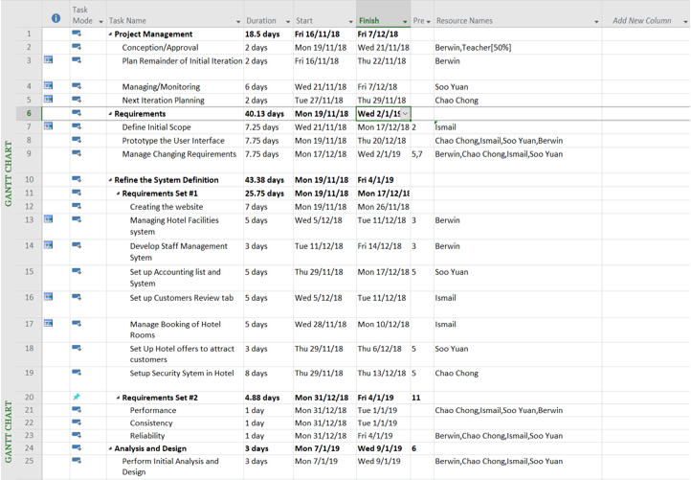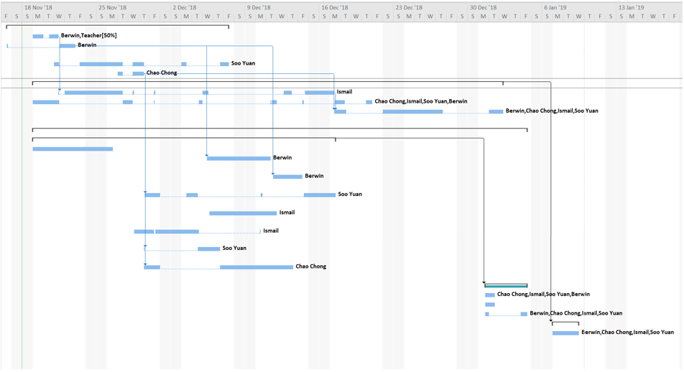

3.3 Budget Summary

|  |  |  |  |
| --- | --- | --- | --- |
| *Name* | *Man Hours(h)* | *Rate(SGD)/h* | *Cost* |
| *Ismail* | *100* | *40* | *4000* |
| *Soo Yuan* | *100* | *40* | *4000* |
| *Berwin* | *100* | *40* | *4000* |
| *Chao Chong* | *100* | *40* | *4000* |
| *Total* | *400* | *-* | *16000* |

|  |  |
| --- | --- |
| *Resource* | *Cost(SGD)* |
| *Dell Poweredge T20* | *1000* |
| *ACER A114-32-C79Z (BLACK) 14 IN INTEL CELERON N4100 4GB 64GB EMMC WIN 10* | *400* |
| *TP-LINK - Talon AD7200 Multi-Band Wi-Fi Router* | *500* |
| *Total* | *1900* |

**Total cost of Project**

16000SGD+1900SGD=17900SGD

4 Risk Management Plan

The Development model that my team will be adopting for the project will be waterfall. As Waterfall has a more traditional approach to manage it. During a project execution a risk can occur any time as it is an uncertain or unknown event that has either a positive or negative impact on the project. So hence it should be constantly monitored and controlled in any waterfall projects for it to be successful. So Risk management is always a crucial part of doing a project. This is to attract an opportunity that has positive impact and decrease the probability of threat that has negative impact to project. Having more opportunities with less threat signify a stable project in term of Time, Scope, Cost And Quality of your project. Risk can be of 2 categories Known and Unknown.

Risk Management for waterfall has a few parts to it.

1. **Plan for Both Known and Unknown Risk**  
   The first step planning for both known and unknown risks in advance, it means planning and managing risks on the basis of Priority and Impact analysis. It is basically conducted at the time of Project Planning. Risk Planning follow the following steps.
   1. Define tools and method used for Risk Management
   2. Define roles and responsibility of Risk Management Teams
   3. Look on budgeting for Risk Management
   4. Define the threshold time frame for the risk to be resolved
   5. Define RISK Categories and prepare RISK breakdown structure.
   6. Prioritize Risk by probability and Impact analysis.
   7. Find out stakeholder risk tolerance.
2. **Identify A Risk: By Following Methods**
   1. Brainstorming, Delphi and SWOT Analysis
   2. Checklist and Assumption Analysis
   3. Process flow chart and Cause and Effect Diagram( Root Cause, Fishbone analysis)

1. **Making An Analysis- Qualitative And Quantitative**
   1. Probability and Impact Matrix
   2. Categorization method
   3. Probability Distribution
   4. Expert Judgment
   5. Sensitive Analysis
   6. EMV Analysis( Expected Monetary Value)
   7. Decision Tree Analysis
   8. Simulating the risk to mitigate plan
2. **Plan For RIsk Response And Mitigation**
   1. Avoid-Transfer-Mitigate Negative Risks
   2. Exploit-Share-Enhance Positive Risks